
Apartment Management System
SRS

Instructor:
Eng. Rasheed Aldhaferi

Made By:
Mohammed Alsamawi
Aiham Alhalmi

Table Of Contents
1. Project Idea 4
Problem Statement 4
Target Users 4
Main Features 4
Scope Boundary 4
2. SRS Chapter 1 – Introduction 4
Purpose 4
Document Conventions 5
Intended Audience 5
Project Scope 5
References 6
Overview 6
3. SRS Chapter 2 – Overall Description 7
Product Perspective 7
Product Features 7
User Classes and Characteristics 7
Operating Environment 7
Design and Implementation Constraints 7
User Documentation 7
Assumptions and Dependencies 8
4. Functional Requirements 9
5. User Stories 11
6. Acceptance Criteria 11
7. Detailed Use Case Descriptions 13
UC-001: Register New Tenant 13
UC-002: Record Rent Payment 13
UC-003: Log Maintenance Issue 14
UC-004: Check In Package 14
8. Interface Requirements 15
9. Nonfunctional Requirements 16
10. Business Rules 17
11. Data Requirements 17
Tenants 18
Apartments 18
PaymentRecords 18
12. Use Case Diagram 19
13. Process Flow / Activity Diagram 20
14. Swimlane Diagram 21
15. Sequence Diagram 23
16. State Diagram 24
17. Issues 26
Issues 26
Packages 26
Users 27
Roles 27
Storage and Integrity Requirements 27

Project Idea
Apartment Management System (AMS) is a desktop-based, local-first property management software product.

Problem Statement
Local apartment building managers and owners often rely on paper ledgers, fragmented logs, and memory to track rent, vacancies, package deliveries, and repair requests. This creates duplicated records, delayed follow-up, unclear balances, and limited visibility into building operations. AMS will digitize and centralize these operations in a single Windows desktop application that remains usable without internet access.

Target Users
User | Role in AMS | Primary Needs
Building Managers | Primary operational users | Maintain apartments and tenants, record rent, log issues, receive packages, and view summaries.
Building Owners | Business owners and administrators | Review financial and operational status, manage users, and control backup/restore.
Apartment Tenants | Secondary beneficiaries | Receive accurate rent records, package pickup confirmation, and issue follow-up.

Main Features
Module | Main Features
Apartment & Occupancy Management | Create units, map rooms, assign tenants, track vacancies and occupancy status.
Rent & Payment Tracking | Compute local rent, record cash/docket payments, classify payment status, calculate overdue balances.
Maintenance & Issue Logging | Create repair requests, classify priority, assign responsibility, and move issues Open → In Progress → Resolved.
Package & Package Receiving | Check in packages, record courier/tracking data, confirm tenant pickup, and search package history.
Local Database (MSSQL Server) & Persistence Layer | Database (MSSQL Server) storage, ACID transactions, local authentication, role permissions, backup and restore.
Approved Changes | CR-002 PDF report export and CR-003 Arabic/English UI toggle.

Scope Boundary
AMS is strictly offline-capable and intended for one local apartment-building operation in V1.0. Online payments, cloud synchronization, mobile applications, SMS/email gateways, and multi-building SaaS are out of scope.

SRS Chapter 1 – Introduction

Purpose
This Software Requirements Specification (SRS) defines the functional, nonfunctional, business, interface, data, and use-case requirements for the Apartment Management System. It provides a shared agreement among the project sponsor, project team, building managers, building owners, and other stakeholders about what the system shall do and the boundaries within which it shall operate.

Document Conventions
This document uses a structured numbering format for requirements. Functional requirements are identified using FR-XXX, nonfunctional requirements using NFR-XXX, business rules using BR-XXX, interface requirements using IR-XXX, data requirements using DR-XXX, open issues using ISS-XXX, and approved scope changes using CR-XXX (matching the project's official Change Log, e.g. CR-001, CR-002, CR-003). Priorities are classified as Must Have, Should Have, Could Have, and Future Enhancement. Tables and diagrams are used throughout the document to improve clarity.
Artifact | ID Pattern | Example
Functional requirement | FR-### | FR-001
Nonfunctional requirement | NFR-### | NFR-001
Business rule | BR-### | BR-001
Interface requirement | IR-### | IR-001
Data requirement | DR-### | DR-001
Use case | UC-### | UC-001
Issue | ISS-### | ISS-001

Priority | Meaning
Must Have | Required for the system to work
Should Have | Important but not critical
Could Have | Useful but optional
Future Enhancement | Not included in the current version (V1.0)

Intended Audience
Audience | Main Interest
Building Owners (Stakeholders) | Scope, features, and business value
Building / Property Managers (End Users) | Daily operational features and usability
Developers | Functional requirements, database (MSSQL Server) schema.
UI / UX Designer | Interfaces Requirements
Testers | Requirements, acceptance criteria, and testing basis
Eng. Rasheed Aldhaferi (Instructor / Sponsor) | Completeness, clarity, and quality of the SRS

Project Scope
AMS covers local apartment and occupancy records, rent and payment tracking, maintenance issue logging, package receiving, local Database (MSSQL Server) persistence, authentication, role control, backup/restore, PDF report export (CR-002), and Arabic/English UI toggle (CR-003). The system shall support Windows 10/11 desktop operation and 100% offline capability. Online payments, cloud sync, mobile apps, SMS/email gateways, and multi-building SaaS are explicitly excluded.
In Scope | Out of Scope
Apartment & occupancy management (Vacant / Occupied / Maintenance) | Online payment gateways (Jaib, OneCash,, banking APIs) — CR-001 Rejected
Rent & payment tracking (cash / dockets, overdue balances, receipts) | Cloud database (MSSQL Server) synchronization and remote APIs
Maintenance & issue logging (Open / In Progress / Resolved) | Tenant mobile applications (iOS / Android)
Package & package receiving and pickup tracking | Automated SMS / email notification gateways
Local offline database (MSSQL Server) with backup and restore utilities | Multi-building enterprise SaaS multi-tenancy
PDF export of maintenance reports (CR-002, Approved)
Arabic / English UI localization (CR-003, Approved)

References
IEEE-style SRS structure and terminology used in the Software Engineering Tutorial lab manuals.
AMS project idea and approved change requests CR-002 and CR-003 supplied by the project team.
ITPM Documentation.
database (MSSQL Server) technology and ACID transaction principles selected as project implementation constraints.

Overview
SRS chapter 2 describes the overall product, users, operating environment, constraints, documentation, assumptions, and dependencies. The Functional Requirements, Interface Requirements, and Nonfunctional Requirements sections define the systems required behavior, external interactions, and quality conditions. The Business Rules and Data Requirements sections specify the policies, restrictions, information, validation rules, and storage needs that apply to the system. The User Stories, Acceptance Criteria, Use Case Diagram, Detailed Use Case Descriptions, Process Flow / Activity Diagram, Swimlane Diagram, Sequence Diagram, and State Diagram provide supporting user-centered, testable, and behavioral models. Finally, the Issues / Open Questions section records unresolved requirements, pending decisions, unclear rules, and assumptions requiring confirmation

SRS Chapter 2 – Overall Description

Product Perspective
AMS is a standalone Windows desktop application for a local apartment-building operation. It replaces disconnected paper ledgers and informal logs with a unified user interface and local Database (MSSQL Server) persistence layer. The product is local-first: core operations do not require internet, external services, or cloud accounts.

Product Features
Feature Area | Description | Priority
Occupancy | Apartment/unit setup, room mapping, tenant assignment, and status dashboard. | Must Have
Rent | Rent calculation, cash/docket payment records, payment status, overdue balance, reports. | Must Have
Maintenance | Issue creation, priority, assignment, status workflow, resolution notes. | Must Have
Packages | Package check-in, tracking details, storage location, pickup confirmation. | Must Have
Persistence and Security | Database (MSSQL Server), ACID transactions, authentication, roles, backup/restore. | Must Have
Approved Enhancements | PDF report export and Arabic/English UI toggle. | Should Have

User Classes and Characteristics
User Class | Characteristics and Responsibilities
Building Manager | Frequent operational user; maintains records and processes daily transactions.
Building Owner | Administrative and oversight user; reviews reports, manages access, and controls backups.
Apartment Tenant | Secondary beneficiary; receives accurate records and service follow-up, but is not a primary V1.0 operator.

Operating Environment
Windows 10 or Windows 11 desktop, supported 64-bit environment. Local Database (MSSQL Server) database (MSSQL Server) stored on the same managed computer or approved local storage. Keyboard and mouse input with a standard desktop display. Optional local printer or PDF-capable print workflow for reports. No internet connection, web server, mobile device, SMS gateway, or cloud service is required.

Design and Implementation Constraints
The product must be 100% offline-capable for core operations. Database (MSSQL Server) is the required local persistence technology and transactions must preserve ACID behavior. Access is controlled through local authentication and role permissions. The first version supports one local building operation; multi-building SaaS is excluded. Approved changes are limited to CR-002 PDF export and CR-003 Arabic/English UI toggle.

User Documentation
The delivery shall include a concise manager guide, owner administration guide, backup/restore instructions, field definitions, and in-application validation/help text. Documentation shall explain common workflows without assuming technical knowledge.

Assumptions and Dependencies
Item | Assumption / Dependency | Impact
Users | Managers and owners have basic Windows and data-entry skills. | Training remains short and task-focused.
Building data | Apartment numbers, room maps, rent rules, and tenant details are supplied by the owner. | Initial setup depends on accurate source records.
Hardware | The target computer has sufficient storage and a supported Windows version. | Performance and backup depend on local hardware.
Policy | Cash/docket payment and package confirmation policies are defined by the building owner. | Business rules must be confirmed before release.
Localization | Arabic and English labels are prepared for CR-003. | Translation completeness affects usability.

Functional Requirements
The following requirements describe observable AMS behavior. Each statement is uniquely identified, testable, and assigned a priority and source. “Must Have” requirements define the V1.0 baseline; “Should Have” requirements are approved or high-value additions.
ID | Requirement Statement | Priority | Source
FR-001 | The system shall allow the Apartment Manager to create an apartment record specifying a unique apartment number, building block, and floor | Must Have | Building Manager
FR-002 | The system shall allow the Apartment Manager to record room counts and room layout descriptions as descriptive fields on an apartment record | Must Have | Building Manager
FR-003 | The system shall calculate and update the apartment occupancy status as Vacant, Occupied, or Under Maintenance based on active tenant assignments. | Must Have | Building Manager
FR-004 | The system shall allow the Apartment Manager to assign an active tenant to an apartment by creating an assignment record with a move-in date. | Must Have | Building Manager
FR-005 | The system shall allow the Apartment Manager to record a tenant move-out date, updating the assignment status to Historical while preserving all historical records. | Must Have | Business Rule
FR-006 | The system shall allow the Apartment Manager to search an filter apartment records by apartment number, occupancy status, and assigned tenant name. | Should Have | Building Manager
FR-007 | The system shall calculate the current rent amount from the apartment rent configuration and applicable period. | Must Have | Building Manager
FR-008 | The system shall allow the Apartment Manager to record a payment transaction (Payment Record) Specifying tenant, apartment, rent period, amount, payment method. | Must Have | Building Manager
FR-009 | The system shall automatically calculate and update the status of a monthly RentPeriod as Unpaid, Partial, Paid, Overdue, or Overpaid based on due date, expected rent, and valid payments sum | Must Have | Business Rule
FR-010 | The system shall calculate the net balance for a rent period as Expected Amount minus Total Paid, registering any positive excess as an overpayment credit balance. | Must Have | Building Manager
FR-011 | The system shall allow the Apartment Manager or Owner to void or correct a PaymentRecord while requiring a mandatory audit note and maintaining transaction log auditability. | Should Have | Building Owner
FR-012 | The system shall allow the Apartment Manager to generate and export monthly rent roll, payment history, and balance report in PDF format | Should Have | CR-002
FR-013 | The system shall allow the Apartment Manager to log a maintenance issue specifying apartment ID, description, category, priority (Low, Medium, High, Urgent), and reporting tenant source | Must Have | Building Manager
FR-014 | The system shall support issue statuses Open, In Progress, Cancelled, and Resolved. | Must Have | Building Manager
FR-015 | The system shall allow the Apartment Manager to resolve an issue (Requiring a mandatory cancellation reason) or cancelling an issue (requiring a mandatory cancellation reason) | Should Have | Building Manager
FR-016 | The system shall allow the Apartment Manager to filter maintenance issues by status, priority, apartment, and date range. | Should Have | Building Manager
FR-017 | The system shall allow the Apartment Manager to log package check-in details including tenant, courier, tracking number, received date, and storage location. | Must Have | Building Manager
FR-018 | The system shall allow the Apartment Manager to mark a package as Picked Up only after recording pickup date and receiver confirmation. | Must Have | Building Rule
FR-019 | The system shall allow the Apartment Manager to search packages by tracking number, tenant, status, and date. | Should Have | Building Manager
FR-020 | The system shall create, read, update, and archive records in a local Database (MSSQL Server). | Must Have | Technical Constraint
FR-021 | The system shall authenticate users login locally using a username, password, and assigned role. | Must Have | Building Owner
FR-022 | The system shall enforce role permissions for manager, and owner. | Must Have | Building Owner
FR-023 | The system shall allow Apartment Owner, and Manager to perform a database (MSSQL Server) backup and restore. | Must Have | Building Owner
FR-024 | The system shall provide an Arabic/English interface toggle without changing stored business data. | Should Have | CR-003
FR-025 | The system shall show a dashboard summarizing occupancy, outstanding rent, open issues, and uncollected packages. | Should Have | Building Manager

User Stories
Story ID | User Story | Module | Priority
US-001 | As a building manager, I want to create apartments and map their rooms, so that the building inventory is accurate. | Apartment & Occupancy | Must Have
US-002 | As a building manager, I want to assign tenants and see occupancy status, so that I can identify vacancies quickly. | Apartment & Occupancy | Must Have
US-003 | As a building manager, I want to record a cash or docket rent payment, so that each tenant balance is current. | Rent & Payments | Must Have
US-004 | As a building owner, I want rent and overdue reports exported to PDF, so that I can review and share a reliable record. | Rent & Payments | Should Have
US-005 | As a tenant or manager, I want a repair issue to have a priority, so that urgent problems receive attention first. | Maintenance | Must Have
US-006 | As a manager, I want to move an issue from Open to In Progress to Resolved, so that repair progress is traceable. | Maintenance | Must Have
US-007 | As a building manager, I want to check in a package with courier and tracking details, so that deliveries are not lost. | Packages | Must Have
US-008 | As a building manager, I want pickup confirmation recorded, so that package handover is accountable. | Packages | Must Have
US-009 | As a building owner, I want local authentication and role permissions, so that sensitive operations are protected. | Persistence & Security | Must Have
US-010 | As a building owner, I want to back up and restore the local database (MSSQL Server), so that operational records can be recovered. | Persistence & Security | Must Have
US-011 | As a manager, I want an Arabic/English UI toggle, so that users can use the interface comfortably. | Persistence & Security | Should Have
US-012 | As a building manager, I want one dashboard for occupancy, rent, issues, and packages, so that daily decisions are faster. | Cross-module Dashboard | Should Have

Acceptance Criteria
The criteria below use Given/When/Then statements so that selected AMS user stories can be verified through repeatable demonstrations or tests.
Story | AC ID | Given | When | Then
US-001 | AC-001 | a manager is authenticated and the apartment number is unused | the manager saves a new apartment with valid room and rent data | the apartment is stored with Active status and appears in the apartment list
US-002 | AC-002 | an active apartment has capacity and the tenant data is valid | the manager confirms the tenant assignment | the tenant is linked to the apartment and occupancy status is recalculated
US-003 | AC-003 | a tenant and rent period exist and the payment amount is positive | the manager records a cash payment equal to the rent | the payment is saved as Full and the outstanding balance becomes zero
US-003 | AC-004 | a tenant has a nonzero rent balance | the manager records a valid amount less than the rent | the payment is saved as Partial and the remaining balance is displayed
US-005 | AC-005 | an apartment exists and the issue description is valid | the manager creates a Critical issue | the issue is saved as Open with Critical priority and visible attention status
US-006 | AC-006 | an issue is Open and the user has permission | the user starts work and then records valid resolution notes | the status can move to In Progress and then Resolved with timestamps
US-007 | AC-007 | the selected tenant exists | the manager saves courier, received date, and storage location | the package is saved as Received and searchable
US-008 | AC-008 | a package is Received | the manager enters pickup date and receiver confirmation | the package becomes Picked Up and the confirmation is retained
US-009 | AC-009 | a user has a valid active account | the user submits valid credentials | the system grants only the permissions assigned to the user role
US-010 | AC-010 | the owner is authenticated and a valid destination is available | the owner starts a backup | the system creates a restorable backup and reports success
US-011 | AC-011 | Arabic and English resources are installed | the manager changes the language toggle | supported labels and messages change without changing stored records
US-012 | AC-012 | the database (MSSQL Server) contains current operational data | the manager opens the dashboard | occupancy, outstanding rent, open issues, and uncollected packages are summarized

Detailed Use Case Descriptions

UC-001: Register New Tenant
Field | Description
Use Case ID | UC-001
Name | Register New Tenant
Goal | Create a complete tenant record and assign the tenant to an available apartment.
Primary Actor | Building Manager
Preconditions | The manager is authenticated; the apartment exists, is active, and has available capacity.
Postconditions | Tenant and assignment are saved; occupancy status is recalculated; an audit event is recorded.
Trigger | Manager selects New Tenant.
Main Flow | 1. Manager opens the tenant registration form. 2. Manager enters tenant identity and contact details. 3. Manager selects an active apartment and confirms move-in date. 4. System validates required fields, uniqueness, capacity, and assignment rules. 5. System saves the tenant and assignment in one transaction. 6. System updates the apartment occupancy status and shows confirmation.
Alternative Flows | A1. If the apartment is partially occupied but has capacity, the system permits assignment and marks it Partially Occupied.
Exceptions | E1. Missing or invalid required data prevents saving and identifies the fields. E2. The selected apartment has no available capacity; the system rejects the assignment.
Related Requirements | FR-001–FR-005, BR-001–BR-003

UC-002: Record Rent Payment
Field | Description
Use Case ID | UC-002
Name | Record Rent Payment
Goal | Record and classify a tenant rent payment and update the outstanding balance.
Primary Actor | Building Manager
Preconditions | The manager is authenticated; tenant and apartment records exist; the rent period is selected.
Postconditions | Payment record is saved; status and balance are recalculated; receipt reference is available.
Trigger | Manager selects Record Payment.
Main Flow | 1. Manager selects tenant and rent period. 2. System displays configured rent and current balance. 3. Manager enters amount, payment method, date, and receipt reference. 4. System validates amount and payment method. 5. System saves the payment and recalculates balance. 6. System displays Full, Partial, Pending, or Overdue status and confirmation.
Alternative Flows | A1. A partial amount is saved with Partial status and the remaining balance.
Exceptions | E1. Amount is zero, negative, or invalid; the system rejects the entry. E2. An unapproved duplicate receipt reference is entered; the system requests correction.
Related Requirements | FR-007–FR-012, BR-004–BR-007

UC-003: Log Maintenance Issue
Field | Description
Use Case ID | UC-003
Name | Log Maintenance Issue
Goal | Register, prioritize, and route a repair request through its resolution workflow.
Primary Actor | Building Manager
Preconditions | The manager is authenticated; the apartment exists.
Postconditions | Issue is saved as Open; priority and description are visible; assignment/status history can be updated.
Trigger | Manager selects New Issue.
Main Flow | 1. Manager selects the apartment and enters issue description and category.  2. Manager selects Low, Medium, High, or Critical priority.  3. System validates the description and priority.  4. System saves the issue with Open status and timestamp.  5. Manager starts working on fixing the issue and change the issue status to in-progress.  6. Authorized user records resolution notes and changes status to Resolved.
Alternative Flows | A1. A Critical issue is highlighted for immediate attention. A2. A resolved issue may be reopened only with an explanation.
Exceptions | E1. Empty description prevents saving. E2. A non-authorized user cannot change assignment or status.
Related Requirements | FR-013–FR-016, BR-008–BR-009

UC-004: Check In Package
Field | Description
Use Case ID | UC-004
Name | Check In Package
Goal | Record a courier package and later confirm tenant pickup.
Primary Actor | Building Manager
Preconditions | The manager is authenticated; tenant record exists.
Postconditions | Package is saved as Received with storage location; later pickup confirmation changes status to Picked Up.
Trigger | Courier delivers a package to the building.
Main Flow | 1. Manager opens package check-in. 2. Manager selects tenant and enters courier, tracking number, received date, and storage location. 3. System validates tenant and package details. 4. System saves the package with Received status. 5. When tenant collects it, manager opens the package record. 6. Manager records pickup date and receiver confirmation. 7. System changes status to Picked Up and shows confirmation.
Alternative Flows | A1. If no tracking number is supplied, the package may be saved with a blank tracking number.
Exceptions | E1. Unknown tenant prevents check-in. E2. Pickup cannot be confirmed without date and receiver confirmation.
Related Requirements | FR-017–FR-019, BR-010–BR-011

Interface Requirements
Interface requirements define how users, software components, hardware devices, and communication channels interact with AMS.
ID | Statement | Type | Priority
IR-001 | The application shall provide a login screen with username, password, authentication result, and recovery guidance. | User Interface | Must Have
IR-002 | The application shall provide a dashboard with navigation to occupancy, rent, issues, packages, reports, users, and backup/restore according to role. | User Interface | Must Have
IR-003 | Data-entry forms shall display field labels, required-field markers, validation messages, and Save/Cancel actions. | User Interface | Must Have
IR-004 | The interface shall provide an Arabic/English toggle for supported labels and messages. | User Interface | Should Have
IR-005 | The application shall support keyboard navigation and readable tabular lists. | User Interface | Should Have
IR-006 | The software interface shall use Database (MSSQL Server) for local persistence through a controlled data-access layer. | Software Interface | Must Have
IR-007 | The reporting interface shall export selected reports to PDF using the local print/export workflow. | Software Interface | Should Have
IR-008 | The application shall use the Windows file system for approved local database (MSSQL Server) backup and restore files. | Software Interface | Must Have
IR-009 | The application shall support standard keyboard, mouse, monitor, and local printer/PDF output devices. | Hardware Interface | Should Have
IR-010 | Core AMS operations shall not require a network or internet communication interface. | Communication Interface | Must Have
IR-011 | If a future local network integration is considered, it shall be treated as a separately approved change and shall not be assumed by V1.0. | Communication Interface | Must Have

Nonfunctional Requirements
Nonfunctional requirements define the quality attributes and operational constraints that apply to AMS behavior. They are written so that verification can be planned through inspection, demonstration, or testing.
ID | Statement | Category | Priority | Source
NFR-001 | The system shall open the dashboard within 5 seconds on a supported Windows desktop with a database (MSSQL Server) of up to 10,000 active records. | Performance | Must Have | Building Owner
NFR-002 | The system shall save a normal record transaction within 2 seconds after the user confirms it. | Performance | Must Have | Building Manager
NFR-003 | The system shall require authenticated login before protected data or operations are accessible. | Security | Must Have | Building Owner
NFR-004 | The system shall store passwords using a one-way salted hash and shall not display them in plain text. | Security | Must Have | Technical Constraint
NFR-005 | The system shall restrict create, edit, delete, backup, and restore actions according to role permissions. | Security | Must Have | Building Owner
NFR-006 | A trained building manager shall be able to record a common transaction without consulting technical support. | Usability | Must Have | Building Manager
NFR-007 | The interface shall use consistent labels, validation messages, keyboard navigation, and visible save/cancel actions. | Usability | Should Have | Building Manager
NFR-008 | The system shall operate fully offline after installation and shall not depend on internet connectivity for core functions. | Compatibility | Must Have | Project Scope
NFR-009 | The application shall run on supported 64-bit Windows 10 and Windows 11 desktop environments. | Compatibility | Must Have | Project Scope
NFR-010 | The system shall preserve committed records after an application restart or power interruption affecting a completed transaction. | Reliability | Must Have | Building Owner
NFR-011 | The database (MSSQL Server) shall maintain ACID-compliant transactions for related updates. | Reliability | Must Have | Technical Constraint
NFR-012 | Backup and restore shall provide a clear success or failure message and shall not silently overwrite the active database (MSSQL Server). | Reliability | Must Have | Building Owner
NFR-013 | The code shall separate user interface, application logic, and persistence responsibilities. | Maintainability | Should Have | Technical Team
NFR-014 | The system shall log significant authentication, backup, restore, and payment-correction events. | Maintainability | Should Have | Building Owner

Business Rules
Business rules express policies, restrictions, and conditions imposed by the building operation. They control how AMS validates data and transitions between business states.
ID | Rule Statement | Category | Related Requirements
BR-001 | Each apartment number shall be unique within the local building database | Data Integrity | FR-001, FR-020
BR-002 | An active apartment shall not receive a new tenant assignment, occupancy status updates automatically | Occupancy Policy | FR-003, FR-005
BR-003 | Recording a move-out sets the tenant move-out date and keep the tenant profile permanently | Occupancy Policy | FR-004, FR-005
BR-004 | Rent billing cycles occurs monthly starting on the 1st of the month, taken from the active rent rate | Payment Policy | FR-007
BR-005 | The system shall accept multiple individual Payment record toward a single rent period | Payment Policy | FR-008
BR-006 | The rent status is calculated automatically from due date, Expected amount, Total paid | Payment Policy | FR-009
BR-007 | Payments Exceeding expected monthly rent must be recorded in full and registered as an overpayment credit | Payment Policy | FR-010
BR-008 | Maintenance priority shall be Low, Medium, High, or Critical; Critical issues require immediate owner/manager attention. | Maintenance Policy | FR-013
BR-009 | Issue status shall follow Open → In Progress → Resolved; reopening requires an explanation. | Maintenance Workflow | FR-014, FR-015
BR-010 | A package shall not be marked Picked Up without pickup date and receiver confirmation. | Package Policy | FR-017, FR-019
BR-011 | Tracking number shall be recorded when supplied by the courier and shall be unique among active package records. | Package Policy | FR-017, FR-019
BR-012 | Only authorized owner-level users may restore a database (MSSQL Server) backup. | Security Policy | FR-022, FR-023
BR-013 | Saved payment record can't be hard-deleted from the database | Audit Policy | FR-011
BR-014 | AMS V1.0 shall not initiate online payment, cloud synchronization, SMS, or email communication. | Scope Control | NFR-008

Data Requirements
AMS shall store the following entities in Database (MSSQL Server). Primary keys are local identifiers; foreign keys preserve relationships. Dates use a consistent ISO-compatible representation, monetary values use a fixed decimal representation, and required fields shall be validated before commit.

Tenants
Field | Description | Type | Required? | Constraints / Validation
TenantID | Unique Identifier | INTEGER | Yes | PK, required, unique
FullName | Legal name of resident | TEXT | Yes | required, 2–120 chars
PhoneNumber | Primary contact number | TEXT | Yes | optional, validated format
Status | Residency status | TEXT | Yes | Active or Inactive

Apartments
Field | Description | Type | Required? | Constraints / Validation
ApartmentID | Unique primary identifier | INTEGER | Yes | PK, required, unique
UnitNumber | Unique unit identifier | VARCHAR | Yes | required, unique
RoomDetails | Descriptive text of rooms | VARCHAR | Yes | required
FloorLevel | Vertical level of unit | INTEGER | Yes | required, >= 0
OccupancyStatus | Current residency status | VARCHAR | Yes | controlled value set  (Occupied, Vacant, Under-Maintenance)

TenantApartmentAssignment
Field | Description | Type | Required? | Constraints / Validation
AssignmentID | Unique record identifier | INTEGER | Yes | PK, required, unique
TenantID | Link to resident | INTEGER | Yes | FK, required
ApartmentID | Link to Unit | INTEGER | Yes | FK, required
MoveInDate | Occupancy start date | VARCHAR | Yes | -
MoveOutDate | Occupancy end date | VARCHAR | No | Must be > MoveInDate

RentConfiguration
Field | Description | Type | Required? | Constraints / Validation
ConfigID | Unique price record ID | INTEGER | Yes | PK, required, unique
ApartmentID | Link to unit | INTEGER | Yes | FK, required
RentAmount | Fixed monthly rate | DECIMAL | Yes | Must be > 0
EffectiveDate | Date price takes effect | DATE | Yes | -

RentPeriod
Define the financial month. Validates that all rent is due on the first of the month.
Field | Description | Type | Required? | Constraints / Validation
PeriodID | Unique cycle identifier | INTEGER | Yes | PK, required, unique
PeriodMonth | Numeric month index | INTEGER | Yes | Range: 1-12
PeriodYear | Four-digit year | INTEGER | Yes | Format: YYYY
DueDate | Payment deadline | DATE | Yes | Must be the first of the month

PaymentRecords
Field | Description | Type | Required? | Constraints / Validation
PaymentID | Unique Payment ID identifier | INTEGER | Yes | PK, required, unique
TenantID | Link to the payer | INTEGER | Yes | FK, required
ApartmentID | Link to the apartment | INTEGER | Yes | FK, required
AmountPaid | Value received | DECIMAL | Yes | required, > 0
PaymentDate | Timestamp of receipt | DATE | Yes | required
PeriodID | Link to rent cycle | INTEGER | Yes | FK, required
PaymentMethod | The method the money was exchanged | TEXT | Yes | Cash or E-wallet, or Transfer
Status | The payment status | TEXT | Yes | Full, Partial, Pending, Overdue
CorrectionNote | Note to detail a correction to the payment | TEXT | No | required for correction

Issues
Field | Description | Type | Required? | Constraints / Validation
IssueID | Unique Issue identifier | INTEGER | Yes | PK, required, unique
ApartmentID | Link to Apartment that has an issue | INTEGER | Yes | FK, required
TenantID | The tenant reporting the issue | INTEGER | Yes | FK, required
Description | Details of the problem | TEXT | Yes | required, 5–1000 chars
Priority | How urgent is the issue | TEXT | Yes | Low/Medium/High/Urgent
Status | The current status of the issue | TEXT | Yes | Open/In Progress/Resolved
CreatedAt | The date the issue was reported | DATETIME | Yes | required
ResolvedAt | The date the issue was resolved | DATETIME | Yes | nullable
ResolutionNotes | Highlights of the way the issue was resolved and notes | TEXT | Yes | required when Resolved

Packages
Field | Description | Type | Required? | Constraints / Validation
PackageID | Unique Package identifier | INTEGER | Yes | PK, required, unique
TenantID | Link to the tenant that the package is for | INTEGER | Yes | FK, required
CourierName | The name of the delivery who delivered the package | TEXT | No | required, 2–100 chars
ReceivedDate | The date the package was delivered | DATE | Yes | required
StorageLocation | The place the package was stored after delivery | TEXT | Yes | required
Status | The current status of the package | TEXT | Yes | Received/Picked Up/Returned
PickupDate | The date of the tenant picking up the package | DATE | Yes | nullable, required when Picked Up
ReceiverConfirmation | The confirmation from the teant | Boolean | Yes | nullable, required when Picked Up

Users
Field | Description | Type | Required? | Constraints / Validation
UserID | Unique User identifier | INTEGER | Yes | PK, required, unique
Username |  | TEXT | Yes | required, unique
PasswordHash | - | TEXT | Yes | required, never plain text
FullName | - | TEXT | Yes | required
RoleID | Link to the role ID | INTEGER | Yes | FK, required
IsActive | The current activity status of the account | BOOLEAN | Yes | required

Roles
Field | Description | Type | Required? | Constraints / Validation
RoleID | Unique Role identifier | INTEGER | Yes | PK, required, unique
RoleName | The name of the role | TEXT | Yes | required, unique

The models in this appendix support Chapter 3 (System Features) and provide the analysis-level design detail referenced throughout the SRS.

Use Case Diagram
Actors (Apartment Tenant, Building Manager, Building Owner) and their relationships to the nine core AMS use cases, showing the system boundary.
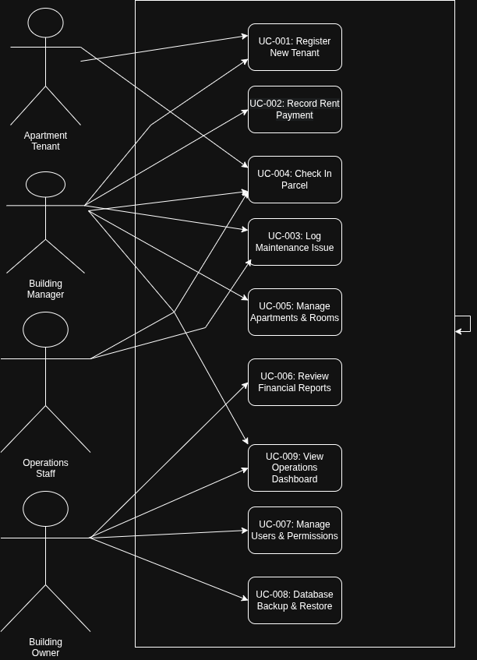
Figure B.1 — AMS Use Case Diagram

Process Flow / Activity Diagram
End-to-end process flow for tenant registration, including validation, capacity checking, and rejection/acceptance branches.
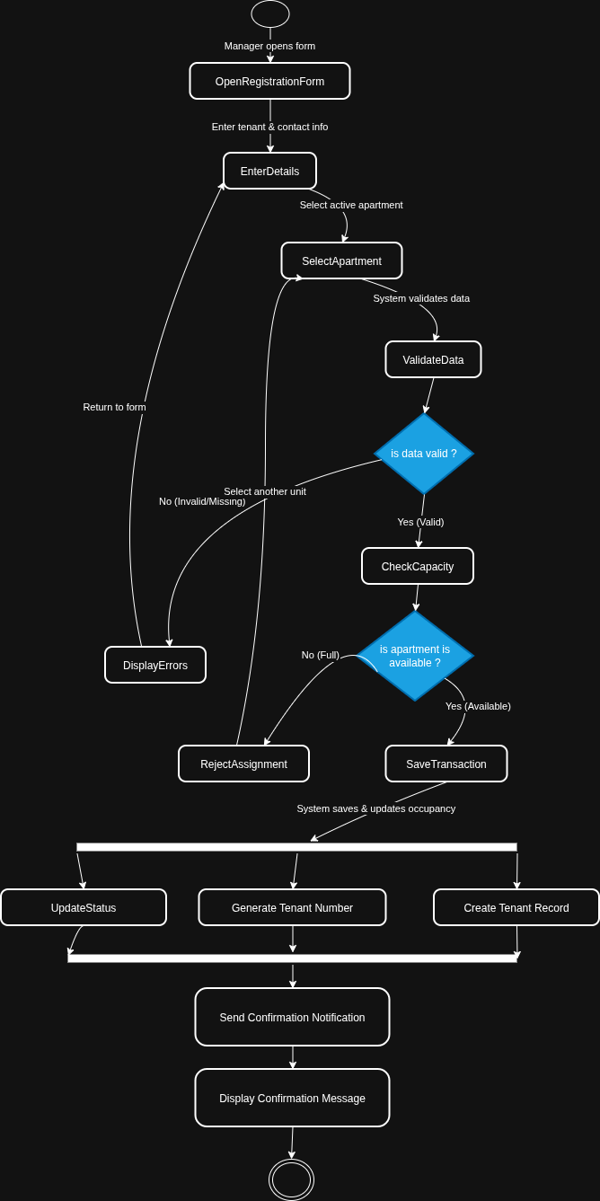
Figure B.2 — Activity Diagram for UC-001: Register New Tenant

Swimlane Diagram
Cross-role workflow for logging and resolving a maintenance issue, showing handoffs between the Building Manager, the AMS System, and Tenants.
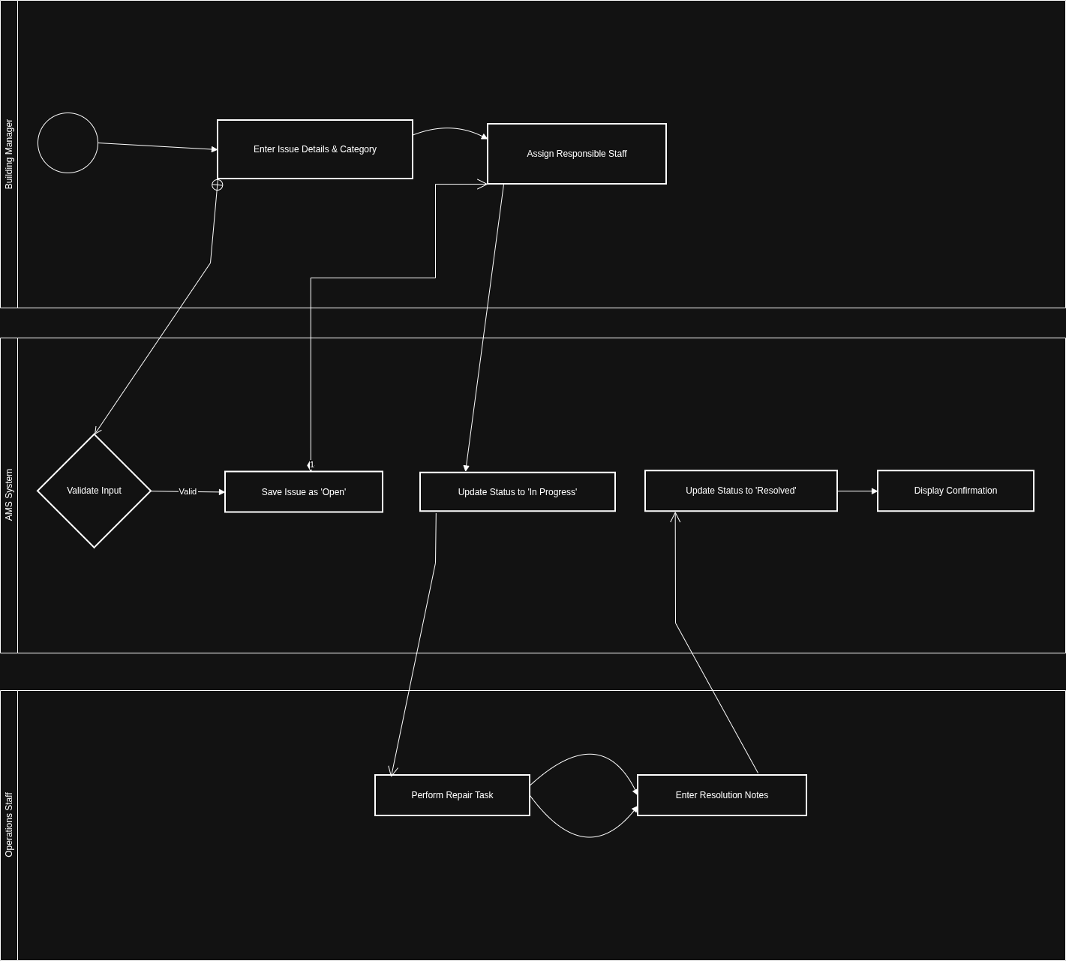
In Scope | Out of Scope
Apartment & occupancy management (Vacant / Occupied / Maintenance) | Online payment gateways (Jaib, OneCash, Stripe, banking APIs) — CR-001 Rejected
Rent & payment tracking (cash / dockets, overdue balances, receipts) | Cloud database (MSSQL Server) synchronization and remote APIs
Maintenance & issue logging (Open / In Progress / Resolved) | Tenant mobile applications (iOS / Android)
Package & parcel receiving and pickup tracking | Automated SMS / email notification gateways
Local offline database (MSSQL Server) with backup and restore utilities | Multi-building enterprise SaaS multi-tenancy
PDF export of maintenance reports (CR-002, Approved)
Arabic / English UI localization (CR-003, Approved)

In Scope | Out of Scope
Apartment & occupancy management (Vacant / Occupied / Maintenance) | Online payment gateways (Jaib, OneCash, Stripe, banking APIs) — CR-001 Rejected
Rent & payment tracking (cash / dockets, overdue balances, receipts) | Cloud database (MSSQL Server) synchronization and remote APIs
Maintenance & issue logging (Open / In Progress / Resolved) | Tenant mobile applications (iOS / Android)
Package & parcel receiving and pickup tracking | Automated SMS / email notification gateways
Local offline database (MSSQL Server) with backup and restore utilities | Multi-building enterprise SaaS multi-tenancy
PDF export of maintenance reports (CR-002, Approved)
Arabic / English UI localization (CR-003, Approved)

Figure B.3 — Swimlane Diagram: Maintenance Issue Workflow

Sequence Diagram
Interaction sequence between the Building Manager, the Payment Form (UI), the Rent Service (Logic), and the Database (MSSQL Server), including the valid/invalid amount alternative.
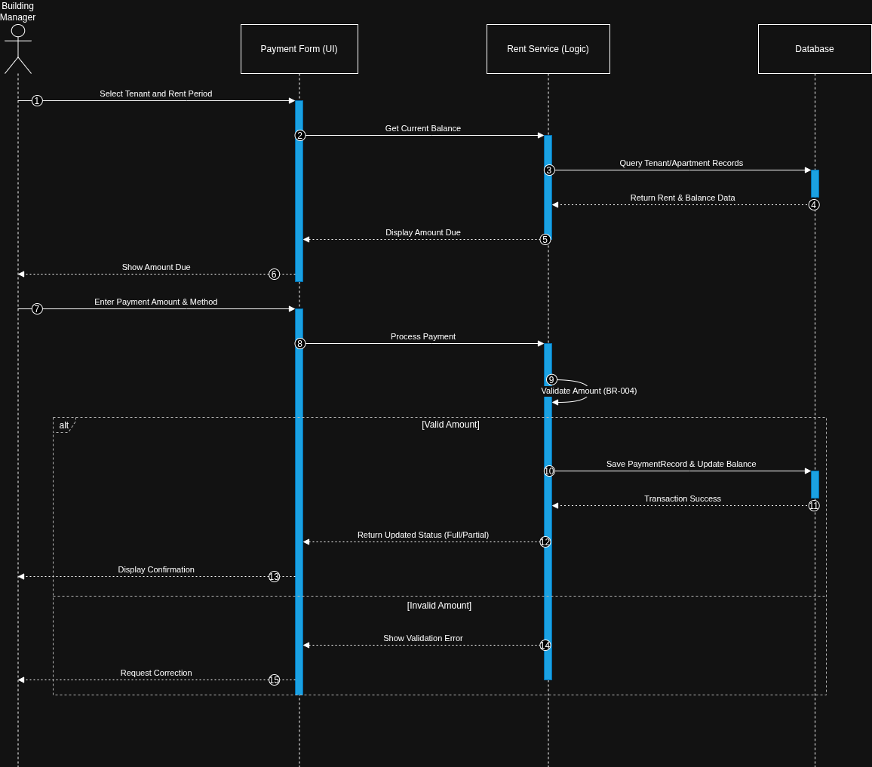
Figure B.4 — Sequence Diagram: Record Rent Payment

State Diagram
Lifecycle states of a maintenance Issue object: Open, Assigned, In Progress, Resolved, and Cancelled, with governing transitions.
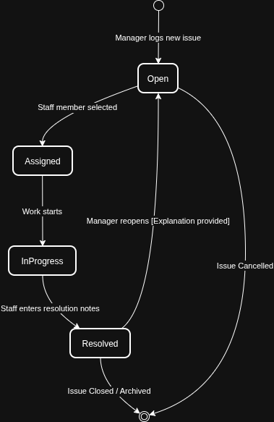
Figure B.5 — State Diagram: Issue Lifecycle

Issues
This register captures unresolved requirements, pending decisions, unclear rules, and assumptions requiring stakeholder confirmation. Owners should resolve high-impact items before baselining the SRS.
ID | Description | Status | Priority | Owner | Impact
ISS-001 | Confirm whether a rent payment requires an ID number and a standard format. | Open | Medium | Building Owners | Affects payment validation and auditability.
ISS-002 | Confirm the approved list of maintenance categories and the definition of Critical priority. | Open | Medium | Aiham Alhalmi | Affects issue classification and escalation.
ISS-003 | Confirm whether package storage locations require a controlled list or free text. | Open | Low | Building Managers | Affects package form design.
ISS-004 | Confirm backup destination policy, retention count, and whether backup files may be stored on removable media. | Open | High | Building Owners | Affects recovery and security procedures.
ISS-005 | Confirm password reset process for a fully offline deployment. | Open | High | Building Owners | Affects account recovery and support.
ISS-006 | Confirm whether tenants will have direct system access in V1.0 or remain secondary beneficiaries. | In Progress | High | Mohammed Alsamawi | Affects user classes, permissions, and UI scope.
ISS-07 | Confirm whether the system should keep an immutable audit history for corrected payments. | Open | Medium | Building Owners | Affects audit data and maintainability.

Storage and Integrity Requirements
ID | Requirement | Category | Priority | Related
DR-001 | The system shall persist all approved entities in a local Database (MSSQL Server) database (MSSQL Server). | Storage | Must Have | FR-020
DR-002 | Primary and foreign keys shall enforce entity identity and valid relationships. | Integrity | Must Have | FR-020
DR-003 | Required fields and controlled values shall be validated before database (MSSQL Server) commit. | Validation | Must Have | FR-001–FR-023
DR-004 | Related changes shall commit atomically or roll back as one transaction. | Integrity | Must Have | NFR-011
DR-005 | Backups shall be restorable and shall retain the database (MSSQL Server) schema and operational records. | Backup | Must Have | FR-023
DR-006 | Archived records shall remain distinguishable from active records and shall not appear in default operational views. | Retention | Should Have | BR-013

